Homework Summary

Student ID | 109590041 | Student Name | 范遠皓
Estimated Time | ___15__ hours
Time Log | Time spent in writing program  - From 20 : 00 to 24 : 00 12/1  - From 10 : 00 to 12 : 00 12/2  - From 20 : 00 to 22 : 00 12/2  - From 20 : 00 to 24 : 00 12/3  - From 20 : 00 to 22 : 00 12/4  - From 22 : 00 to 24 : 00 12/5  - From 17 : 00 to 18 : 00 12/7  Time spent in writing document  - From : to :  - From : to :
Actual Time | ___17__ hours
Difference between Estimated time and Actual Time | __-2___ hours (|Estimated Time – Actual Time|)  __-13.3___ % (|Estimated Time – Actual Time|/ Estimated Time)
Difficulty of the homework
Other Issues | 無

Dr.smell
DrawingApp 的 MainPage 產生的檔案無法消除。
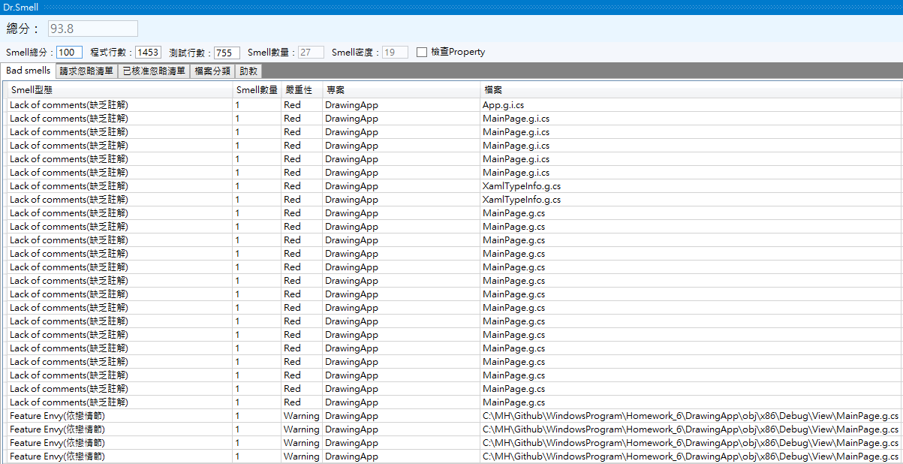
DataBinding
DrawingForm
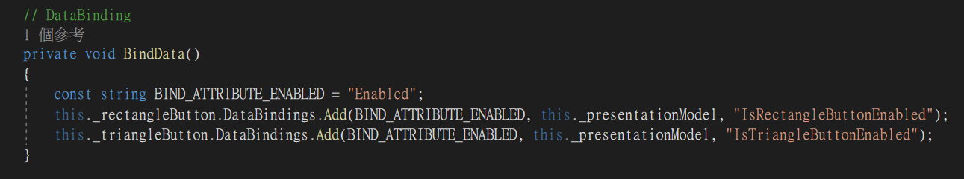
元件 | 屬性
矩形按鈕 | Enabled
三角形按鈕 | Enabled

DrawingApp MainPage
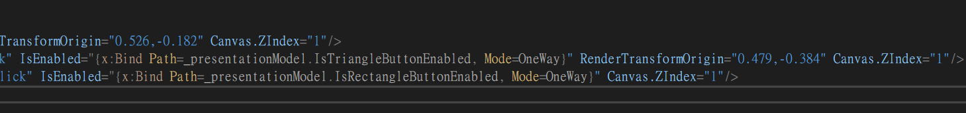
元件 | 屬性
矩形按鈕 | Enabled
三角形按鈕 | Enabled

Unit Test
加入 DrawingApp 單元測試會導致 Fine Code Coverage 無法使用。
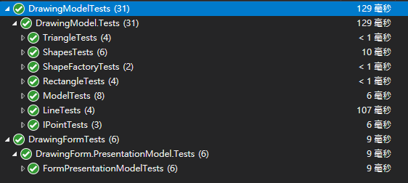
DrawingForm 只測試 PresetationModel，其餘測試在DrawingModelTests。
